**Home**

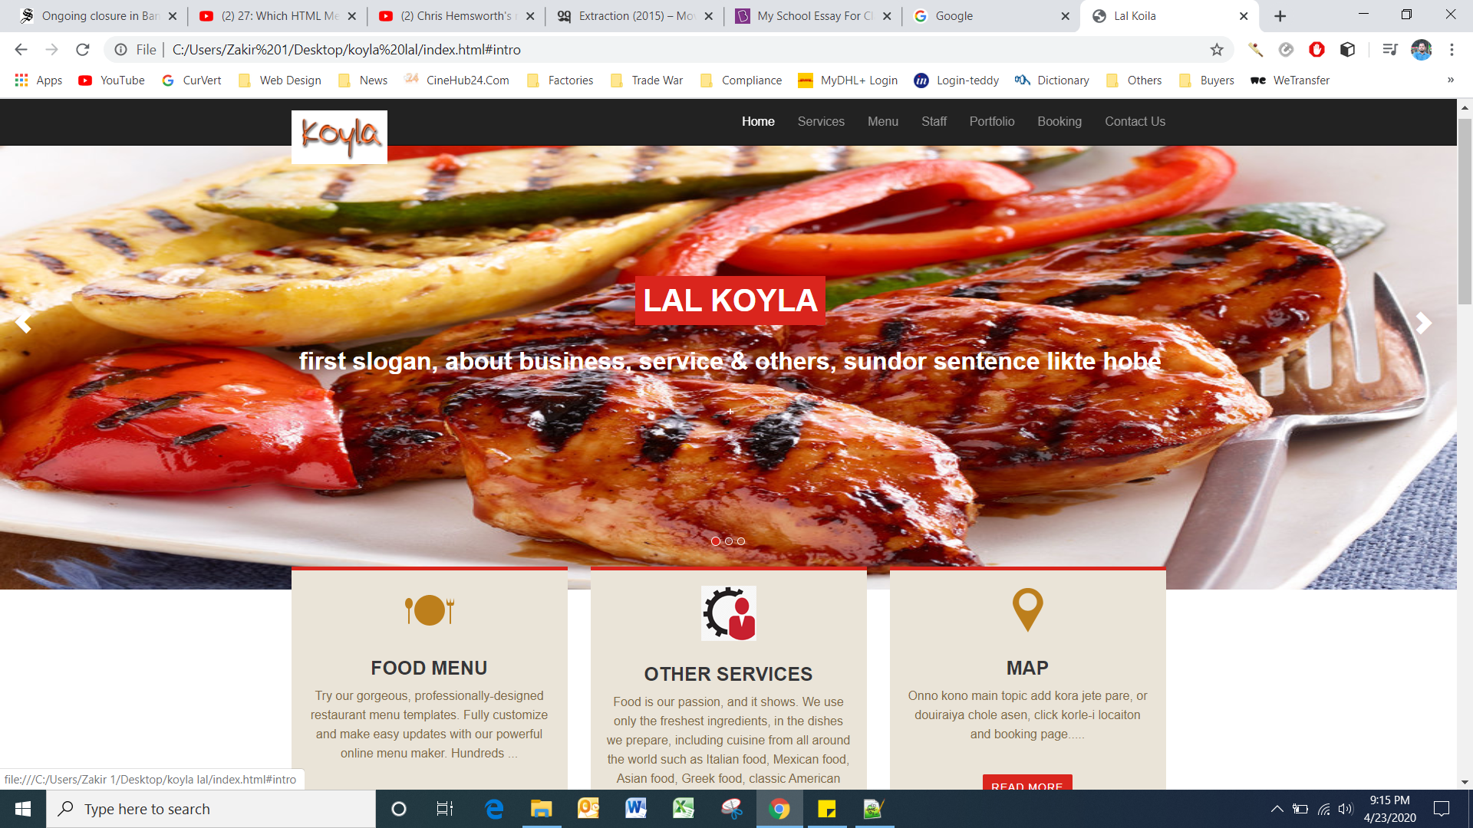

Home-1

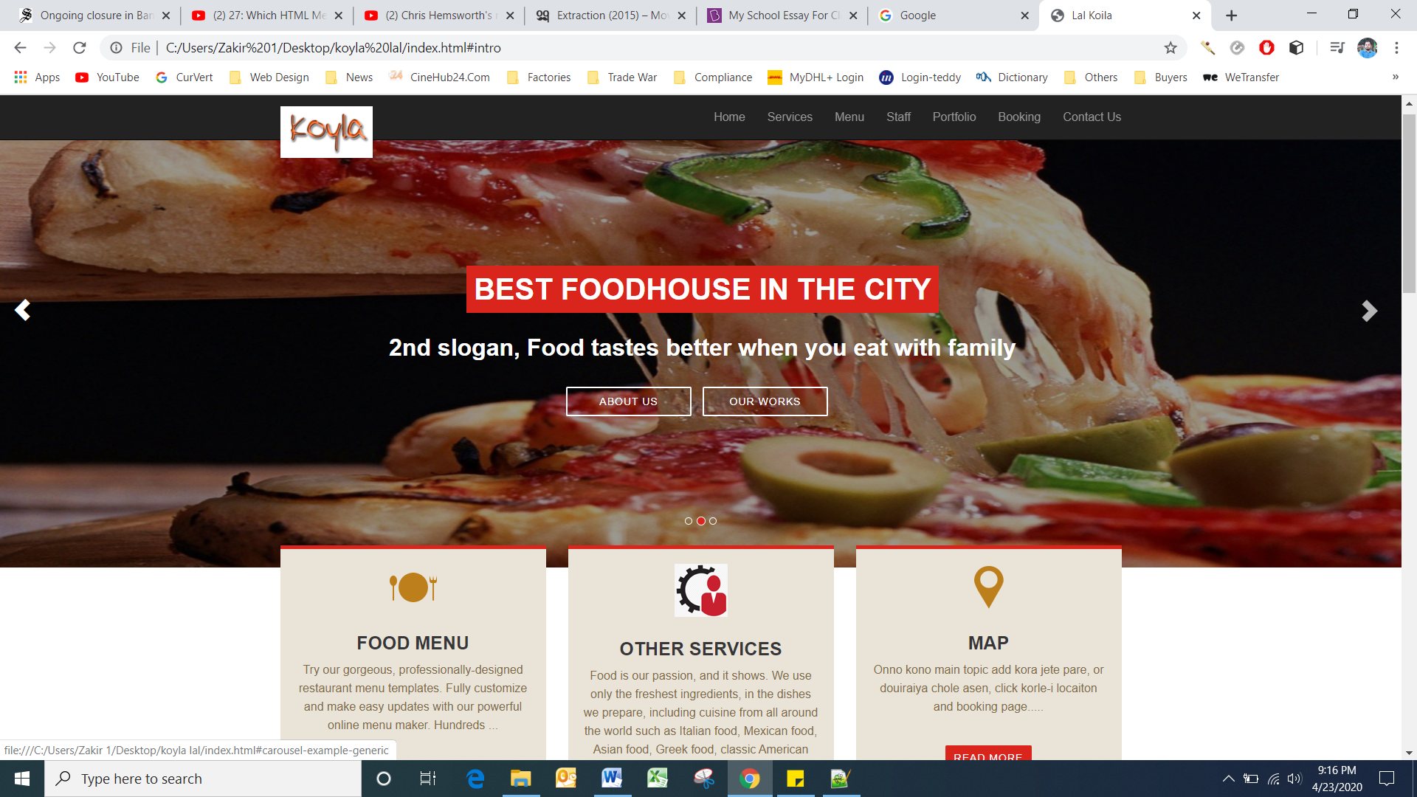

Home-2

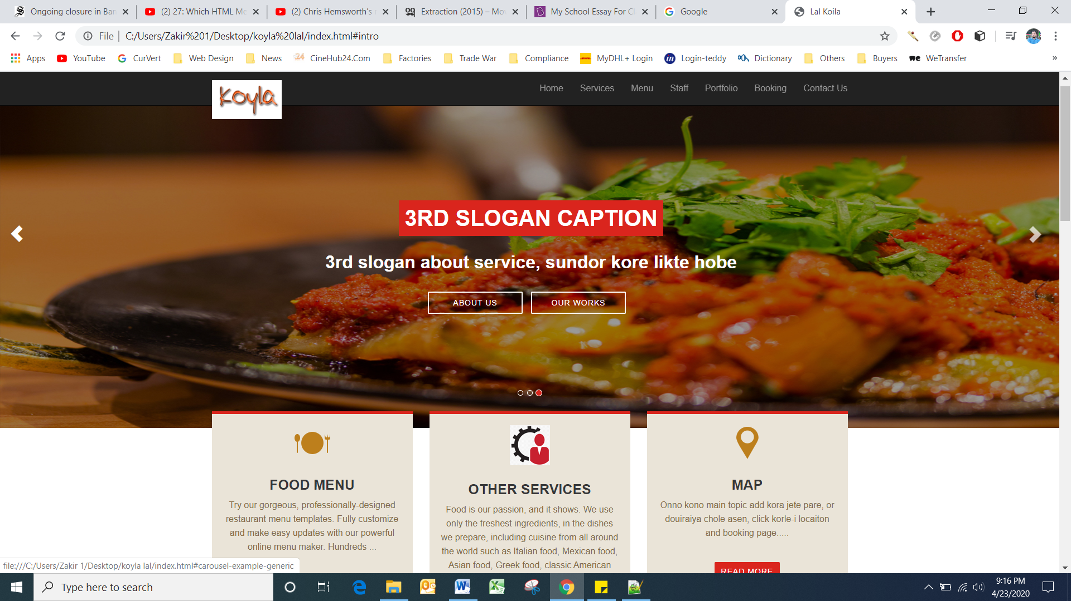

**Job for 1st page**

1. Three pic for front page
2. Three slogan for 3 pic
3. Writing for “FOOD MENU’ ‘OTHER SERVICES AND ‘MAP or I will write as my own

Also you can give idea/suggestion/comments for page design and others

**Menu**

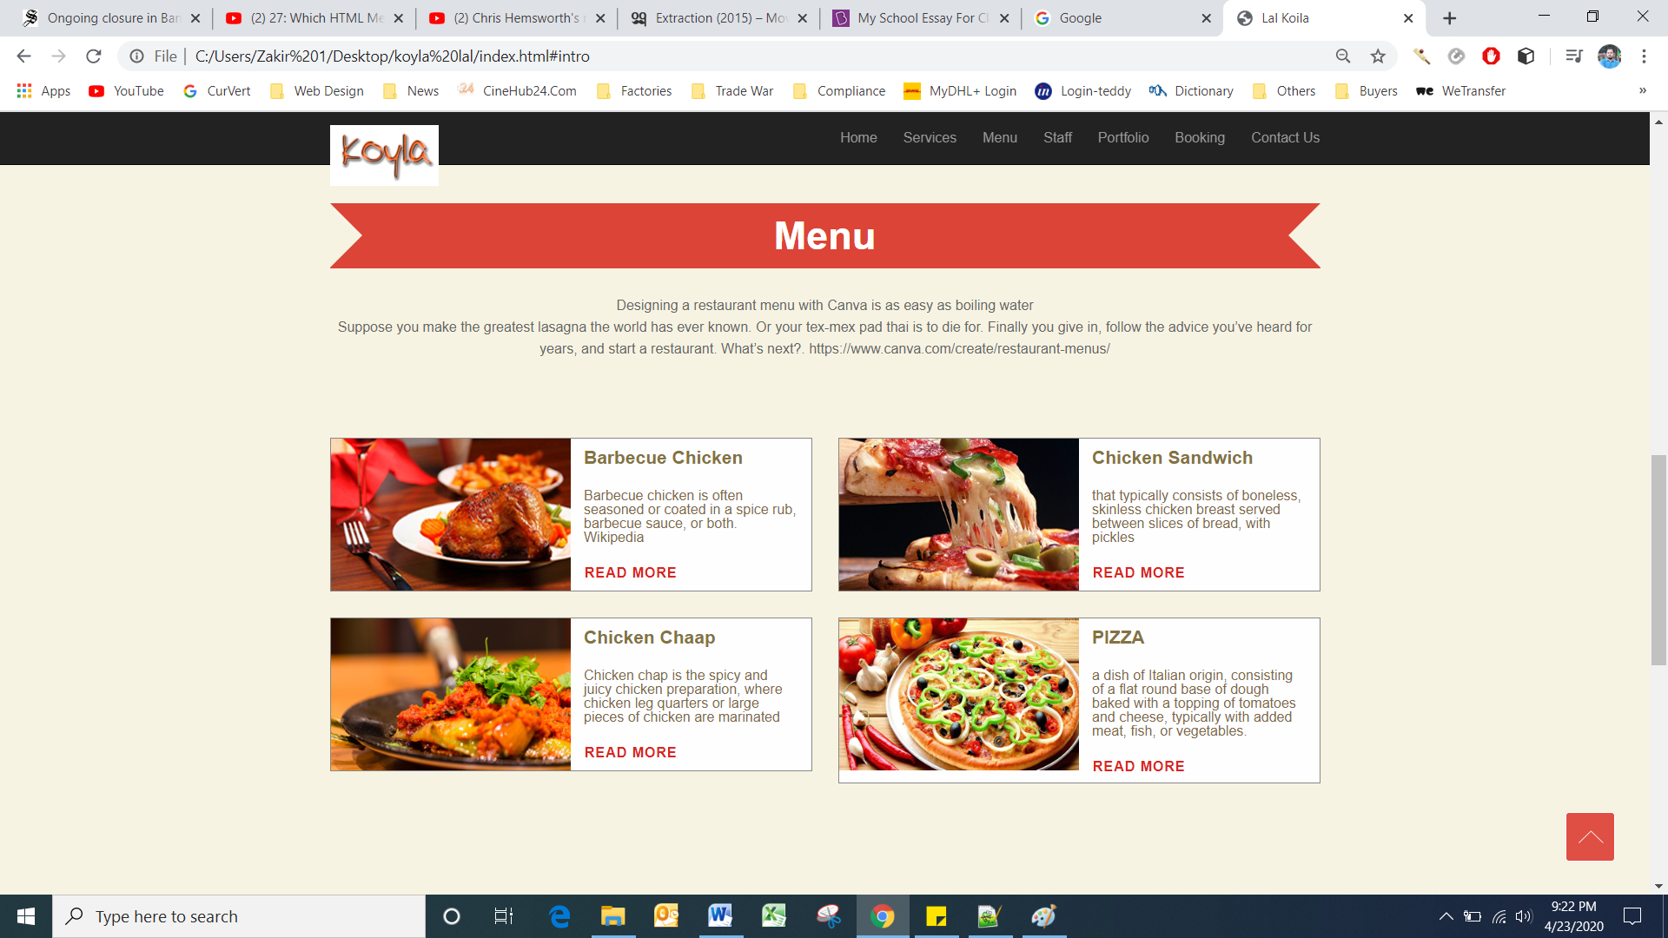

**Job for 2nd page-**

1. Writing for “MENU” body and picture 4 at least, you can add more if you want but
2. Need their details, I mean about food description.

Super Chef

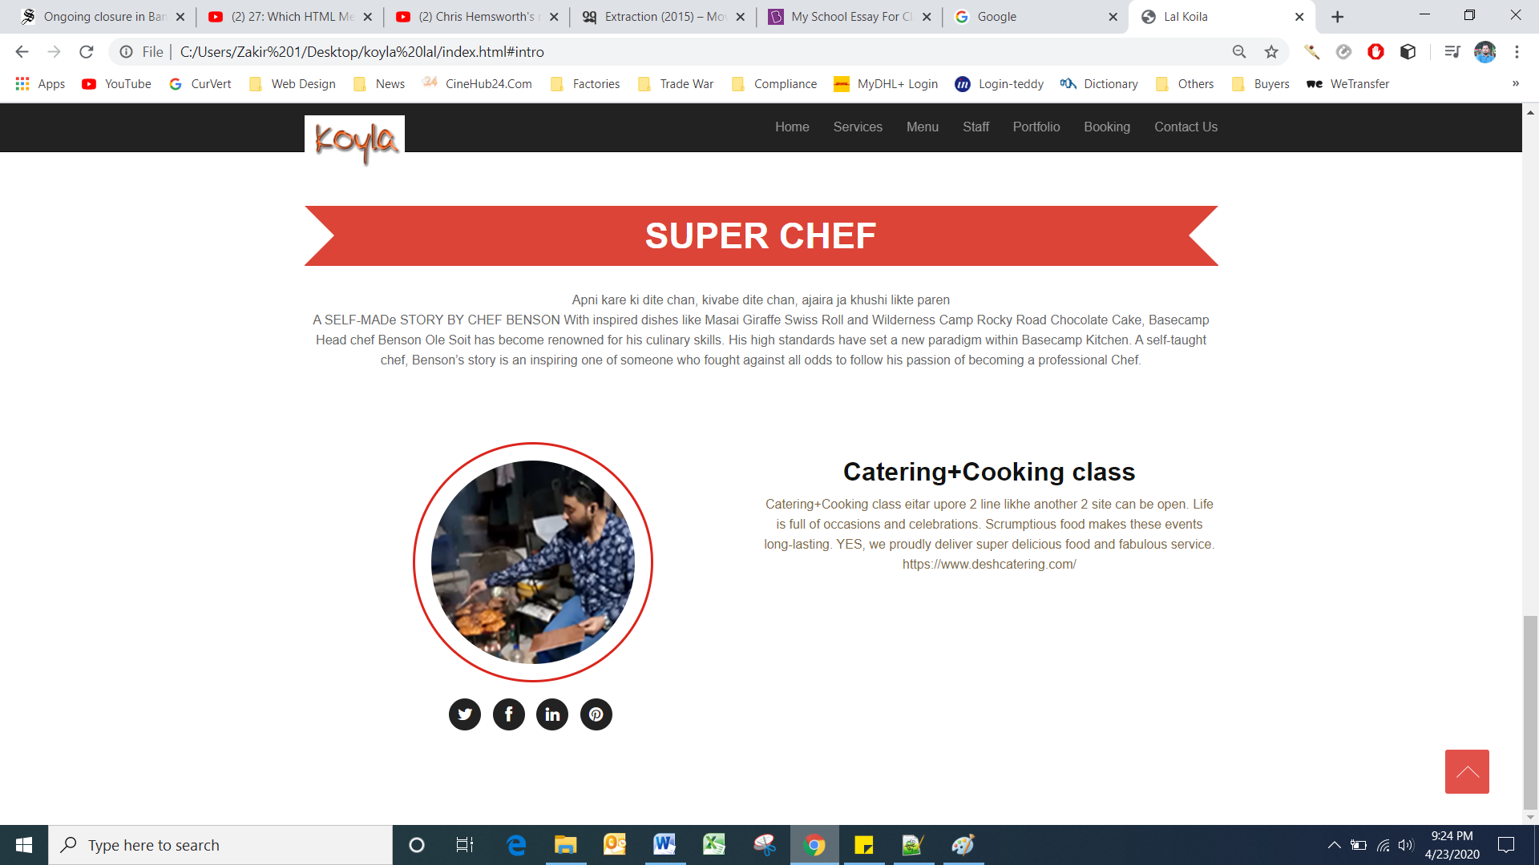

**Job for 3rd page**

1. Writing for body
2. Writing for catering (another site can be open for CATERING)
3. Writing for Cooking class (another site can be open for Cooking class)
4. Also you can add other restaurant related business plan or anything if u want
5. A picture of your cooking, this page still under construction, as I could not figure out this page yet as I want..

Page-4

**Portfolio**

Page-5

**Booking**

Page-6

**Contact us**

Still under construction. Hope to show you something by end of this month..